**HW1**

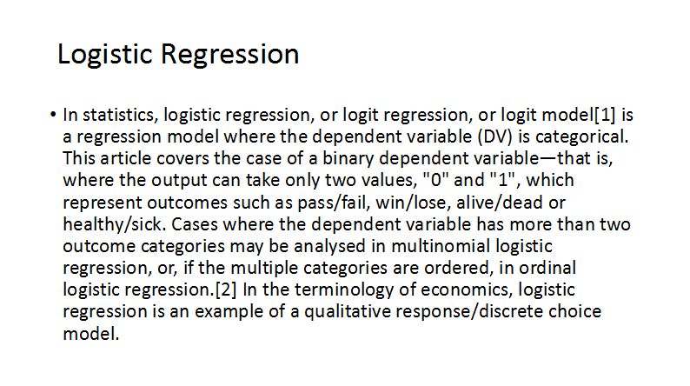

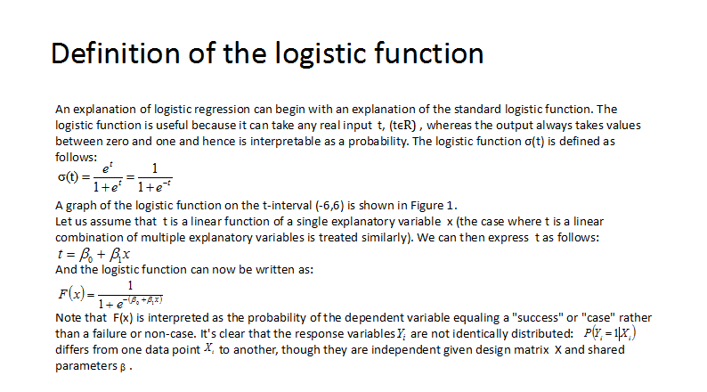

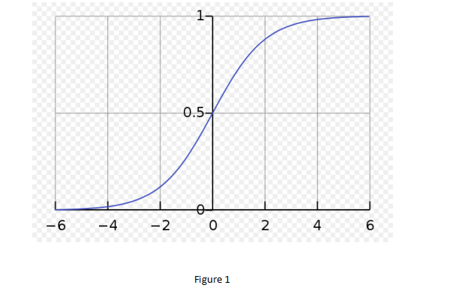

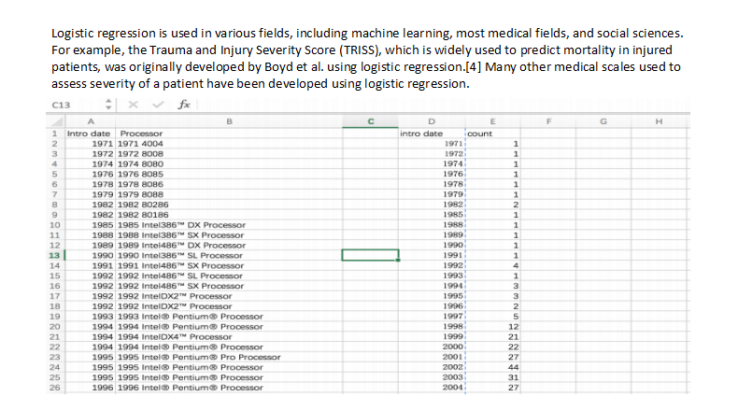

**HW2**

year<-c(1971,1972,1974,1976,1978,1979,1982,1985,1988,1989,1990,1991，1992，1993，1994，1995，1996,1997,1998,1999，2000,2001,2002,2003,2004，2005,2006,2007,2008）

number<-c(1,1,1,1,1,1,2,1,1,1,1,1,4,1,3,3,2,5,12,21,22,27,44,31,27,16,29,44,59)

#HW1#

plot(year,number,type="b"，col="black",main="The history of computer memory",sub="This is the change in the numbere of types of computer memory",xlab="year",ylab="The number of memory")

barplot(number,xlab="year",ylab="The number of money")

#HW2#

#HW3#

lambda=2

x=seq(0:6)

P<-data.frame(dpois(x,lambda))

sum<-(P[1,]+P[7,]+P[2,]+P[6,]+P[3,]+P[5,]+P[4,]+P[4,])

sum

lambda=5

x=0

dpois(x,lambda)

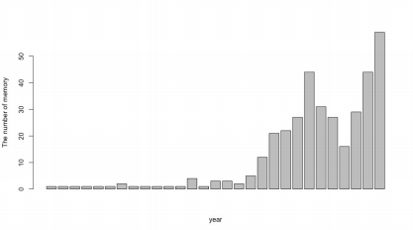

x=6

n=1000

lambda=2

p=lambda/n

dbinom(x,2*n,p)

dpois(x,2*lambda)

dpois(o,5)

**HW3**

#HW3-4#

install.packages("rjson",repos = "http://cran.us.r-project.org")

library("rjson")

json_file="http://crix.hu-berlin.de/data/crix.json"

json_data=fromJSON(file=json_file)

crix_data_frame=as.data.frame(json_data)

crix_data_frame_t<-t(crix_data_frame)

time<-crix_data_frame_t[seq(1,2350,by=2)]

price<-crix_data_frame_t[seq(2,2350,by=2)]

crix_data_frame<-cbind(time,price)

time_series<-ts(data=price,start =c(2014,7,31),frequency = 365)

plot(time_series)

install.packages("tseries")

library(tseries)

adf.test(time_series)

#Because p-value is greater than printed p-value, we can't reject the hypothesis#

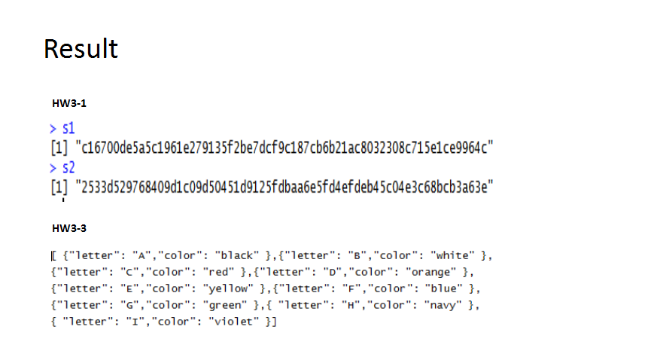

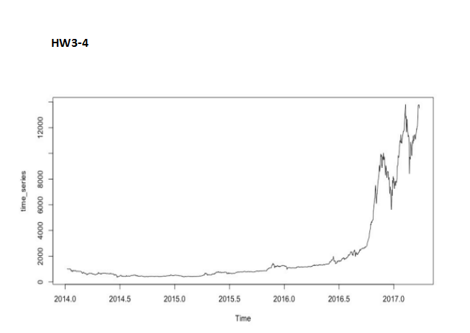

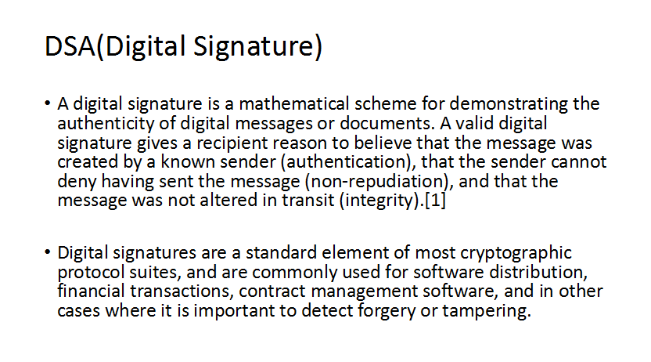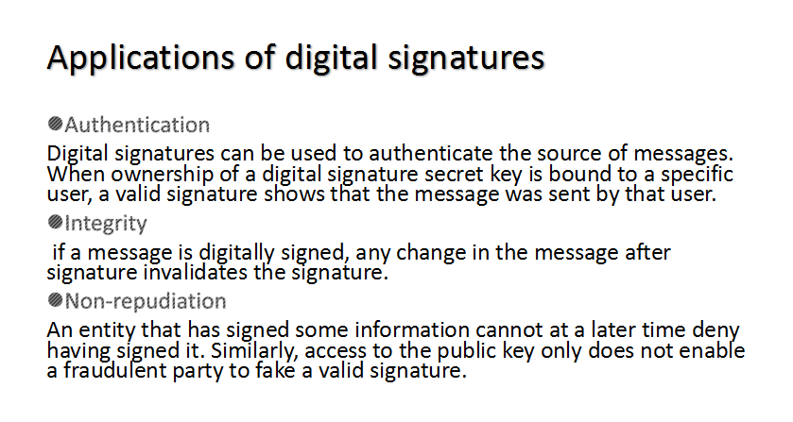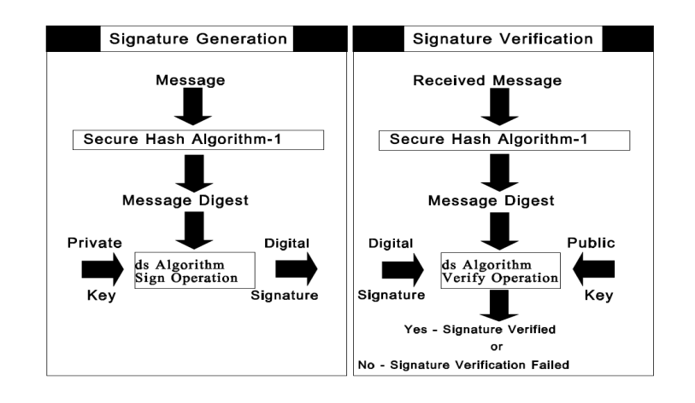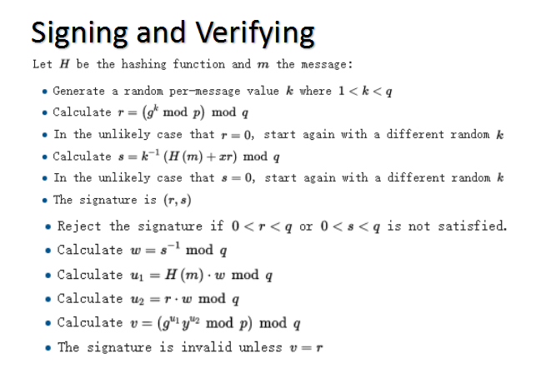

**HW4**

Q1

#20171017 JSON input from CRIX , trial done in XMN

install.packages("rjson",repos="http://cran.us.r-project.org")

library("rjson")

json_file = "http://crix.hu-berlin.de/data/crix.json"

json_data = fromJSON(file=json_file)

crix_data_frame = as.data.frame(json_data)

x = crix_data_frame

n = dim(x)

a = seq(1,n[2],2)

b = seq(2,n[2],2)

#figure 3 : The daily value of CRIX

date = t(x[1,a])

price = t(x[1,b])

plot(price)

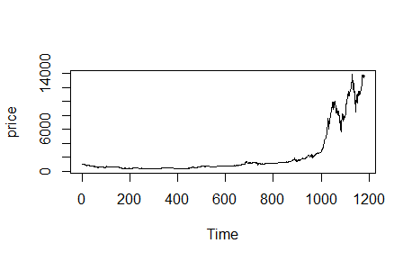

#figure 4 : The log returns of CRIX index

dim(price)

ts.plot(price)

ret = diff( log(price) )

ts.plot( ret )

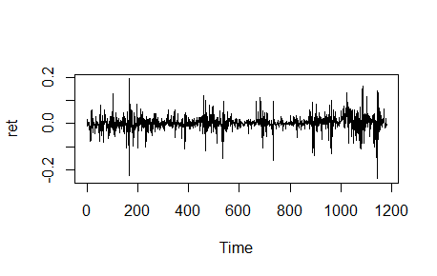

#figure 5 : Histogram

hist(ret, col = "grey", breaks = 20, freq = FALSE, ylim = c(0, 25), xlab = NA)

lines(density(ret), lwd = 2)

mu = mean(ret)l,

sigma = sd(ret)

x = seq(-4, 4, length = 100)

curve(dnorm(x, mean = mean(ret), sd = sd(ret)), add = TRUE, col = "darkblue", lwd = 2)

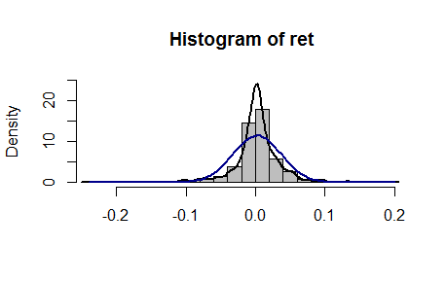

#figure 6 : QQ plot

qqnorm(ret)

qqline(ret, col = "blue", lwd = 3)

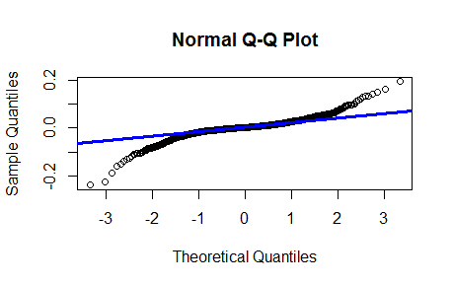

Q2

rm(list = ls(all = TRUE))

graphics.off()

# install and load packages

libraries = c("zoo", "tseries")

lapply(libraries, function(x) if (!(x %in% installed.packages())) {

install.packages(x)

})

lapply(libraries, library, quietly = TRUE, character.only = TRUE)

#RET

("rjson",repos="http://cran.us.r-project.org")

library("rjson")

json_file = "http://crix.hu-berlin.de/data/crix.json"

json_data = fromJSON(file=json_file)

crix_data_frame = as.data.frame(json_data)

x = crix_data_frame

n = dim(x)

a = seq(1,n[2],2)

b = seq(2,n[2],2)

date = t(x[1,a])

price = t(x[1,b])

dim(price)

ret = diff( log(price) )

# d order

Box.test(ret, type = "Ljung-Box", lag = 20)

# stationary test

adf.test(ret, alternative = "stationary")

kpss.test(ret, null = "Trend")

par(mfrow = c(1, 2))

# acf plot

autocorr = acf(ret, lag.max = 20, ylab = "Sample Autocorrelation", main = NA,

lwd = 2, ylim = c(-0.3, 1))

# LB test of linear dependence

print(cbind(autocorr$lag, autocorr$acf))

Box.test(ret, type = "Ljung-Box", lag = 1, fitdf = 0)

Box.test(autocorr$acf, type = "Ljung-Box")

# plot of pacf

autopcorr = pacf(ret, lag.max = 20, ylab = "Sample Partial Autocorrelation",

main = NA, ylim = c(-0.3, 0.3), lwd = 2)

print(cbind(autopcorr$lag, autopcorr$acf))

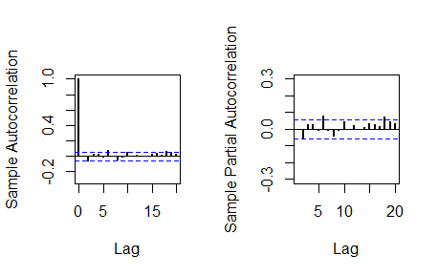

# arima model

par(mfrow = c(1, 1))

auto.arima(ret)

fit1 = arima(ret, order = c(1, 0, 1))

tsdiag(fit1)

Box.test(fit1$residuals, lag = 1)

# aic

aic = matrix(NA, 6, 6)

for (p in 0:4) {

for (q in 0:3) {

a.p.q = arima(ret, order = c(p, 0, q))

aic.p.q = a.p.q$aic

aic[p + 1, q + 1] = aic.p.q

}

}

aic

# bic

bic = matrix(NA, 6, 6)

for (p in 0:4) {

for (q in 0:3) {

b.p.q = arima(ret, order = c(p, 0, q))

bic.p.q = AIC(b.p.q, k = log(length(ret)))

bic[p + 1, q + 1] = bic.p.q

}

}

bic

# select p and q order of ARIMA model

fit4 = arima(ret, order = c(2, 0, 3))

tsdiag(fit4)

Box.test(fit4$residuals, lag = 1)

fitr4 = arima(ret, order = c(2, 1, 3))

tsdiag(fitr4)

Box.test(fitr4$residuals, lag = 1)

# to conclude, 202 is better than 213

fit202 = arima(ret, order = c(2, 0, 2))

tsdiag(fit202)

tsdiag(fit4)

tsdiag(fitr4)

AIC(fit202, k = log(length(ret)))

AIC(fit4, k = log(length(ret)))

AIC(fitr4, k = log(length(ret)))

fit202$aic

fit4$aic

fitr4$aic

# arima202 predict

fit202 = arima(ret, order = c(2, 0, 2))

crpre = predict(fit202, n.ahead = 30)

dates = seq(as.Date("02/08/2014", format = "%d/%m/%Y"), by = "days", length = length(ret))

plot(ret, type = "l", xlim = c(0, 644), ylab = "log return", xlab = "days",

lwd = 1.5)

lines(crpre$pred, col = "red", lwd = 3)

lines(crpre$pred + 2 * crpre$se, col = "red", lty = 3, lwd = 3)

lines(crpre$pred - 2 * crpre$se, col = "red", lty = 3, lwd = 3)

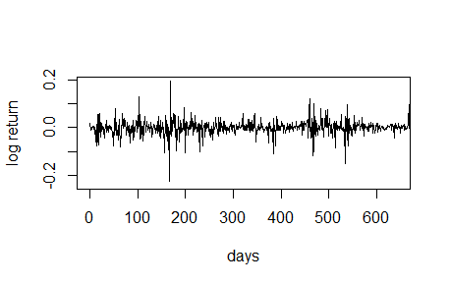

Q3

rm(list = ls(all = TRUE))

graphics.off()

# install and load packages

libraries = c("FinTS", "tseries")

lapply(libraries, function(x) if (!(x %in% installed.packages())) {

install.packages(x)

})

lapply(libraries, library, quietly = TRUE, character.only = TRUE)

# plot of crix return

ret = diff(log(crx$Pr))

Dare = factor(date1[-1])

retts = data.frame(Dare, ret)

# comparison of different crix returns

par(mfrow = c(2, 2))

plot(crx$Da, crx$Pr, type = "o")

lines(crx$Pr)

plot(crx$Da, log(crx$Pr), type = "o")

lines(log(crx$Pr))

plot(retts$Dare, diff(crx$Pr), type = "o")

lines(diff(crx$Pr))

plot(retts$Dare, retts$ret, type = "o")

lines(retts$ret)

# ARIMAfit <- auto.arima(ret, approximation=FALSE,trace=FALSE)

# summary(ARIMAfit)

# arima202 predict

fit202 = arima(ret, order = c(2, 0, 2))

# vola cluster

par(mfrow = c(1, 1))

res = fit202$residuals

res2 = fit202$residuals^2

tsres202 = data.frame(Dare, res2)

plot(tsres202$Dare, tsres202$res2, type = "o", ylab = NA)

lines(tsres202$res2)

par(mfrow = c(1, 2))

# plot(res2, ylab='Squared residuals', main=NA)

acfres2 = acf(res2, main = NA, lag.max = 20, ylab = "Sample Autocorrelation",

lwd = 2)

pacfres2 = pacf(res2, lag.max = 20, ylab = "Sample Partial Autocorrelation",

lwd = 2, main = NA)

# arch effect

res = fit202$residuals

ArchTest(res) #library FinTS

Box.test(res2, type = "Ljung-Box")

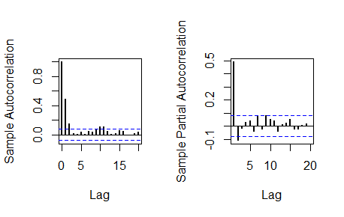

HW 5

Q1&Q2

rm(list = ls())

library(RCurl)

library(XML)

library(bitops)

library(stringr)

url=paste(c("http://publicliterature.org/pdf/2ws1610.pdf","http://publicliterature.org/pdf/2ws2410.pdf","http://publicliterature.org/pdf/2ws3310.pdf") )

abs=lapply(url, FUN = function(x) htmlParse(x, encoding = "Latin-1"))

clean_txt = function(x) {

cleantxt = xpathApply(x, "//body//text()

[not(ancestor :: script)][ not(ancestor :: style)]

[not(ancestor :: noscript)] " ,xmlValue)

cleantxt = paste(cleantxt, collapse="\n")

cleantxt = str_replace_all(cleantxt, "\n", " ")

cleantxt = str_replace_all(cleantxt, "\r", "")

cleantxt = str_replace_all(cleantxt, "\t", "")

cleantxt = str_replace_all(cleantxt, "<br>", "")

return(cleantxt)

}

cleantxt = lapply(abs,clean_txt)

vec_abs = unlist(cleantxt)

vec_abs

library(tm)

library(SnowballC)

abs = Corpus(VectorSource(vec_abs))

abs_dtm = DocumentTermMatrix(abs, control = list(

stemming = TRUE, stopwords = TRUE, minWordLength = 3,

removeNumbers = TRUE, removePunctuation = TRUE))

dim(abs_dtm)

inspect(abs_dtm)

#Find the words that occur more than 5 times

findFreqTerms(abs_dtm, 5)

#Remove sparse terms

removeSparseTerms(abs_dtm, 0.5)

inspect(removeSparseTerms(abs_dtm, 0.5))

library(ggplot2)

library(wordcloud)

freq = colSums(as.matrix(abs_dtm))

wf = data.frame(word=names(freq), freq=freq)

plot = ggplot(subset(wf, freq>100), aes(word, freq))

plot = plot + geom_bar(stat="identity")

plot = plot + theme(axis.text.x=element_text(angle=45, hjust=1))

plot

freq = colSums(as.matrix(abs_dtm))

dark2 = brewer.pal(8, "Dark2")

wordcloud(names(freq), freq, max.words=200, rot.per=0.1, colors=dark2)

dev.off()





hist(freq, col = "grey", breaks = 20,ylim = c(0, 5000), xlab = "freq of words")

